SIMATS ENGINEERING (SAVEETHA SCHOOL OF ENGINEERING)
Department of Computer Science and Engineering

ASSESSMENT TOOL 2 – CASE STUDY

Course Code: | CSA06 | Course Title: | Design and Analysis of Algorithms
CO Assessed: | CO3: Articulation (BL4, BL5) | Assessment: | Assessment Tool 2 – Case Study
Weightage: | 20% of CIA | Total Marks: | 100
CO3 Statement: | Design Divide and Conquer algorithms for Merge Sort, Quick Sort, Binary Search and Matrix Multiplication
Student Name: |  | Reg. No.:
Section / Batch: |  | Date:
Instructions to Students
- Answer the following question. Total Marks: 100.
- Carefully analyze the given case study questions.
- Explain in detail with sample code if needed.
- Clearly identify all key issues, provide an in-depth analysis, and propose innovative, feasible solutions with strong justification.

Question Type | Focus Area | Questions
Case Study | Focus on Design Divide and Conquer algorithms: Merge Sort, Quick Sort, Binary Search and Matrix Multiplication | Q1
SECTION A – CASE STUDY

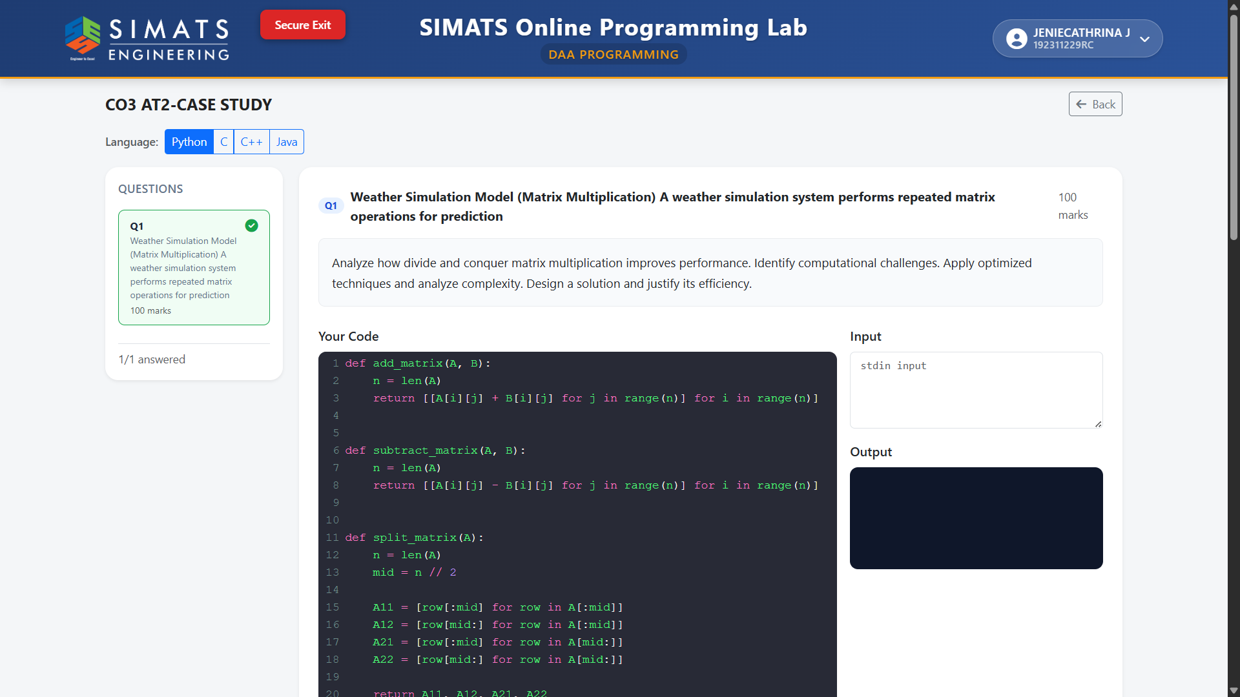

Code of Conduct
I T.Muthu Vaishnavi 192311215(Name / Reg No) certify that this submission is my original work and that I have adhered to the guidelines specified for this assessment. I understand that any violation of academic integrity rules will result in disciplinary action.
Signature of the Student: T.Muthu Vaishnavi
RUBRICS FOR CALCULATION

Case Study
Criteria | Weightage | Level 4 – Exemplary | Level 3 – Proficient | Level 2 – Developing | Level 1 – Beginning
Understanding of Case | 25% | Thorough understanding; clearly identifies all key issues | Good understanding with most issues identified | Basic understanding; some issues missed | Poor understanding; problem not identified correctly
Application of Concepts | 25% | Effectively applies relevant concepts to analyze the case deeply | Applies appropriate concepts with minor gaps | Limited application of concepts | Fails to apply relevant concepts
Analysis | 20% | In-depth analysis with strong  reasoning and insights | Good analysis with logical reasoning | Basic analysis with limited depth | Weak or no analysis; lacks reasoning
Solution Design | 20% | Innovative, feasible solutions with strong justification | Logical solutions with adequate justification | Basic solutions with weak justification | Incorrect or no solution provided
Clarity | 10% | Clear, well-structured, and easy to  understand | Organized and understandable presentation | Limited clarity and structure | Poor clarity; difficult to understand

Marks Evaluation:
Criteria | Wt. | Level 4 – Exemplary | Level 3 – Proficient | Level 2 – Developing | Level 1 – Beginning
Understanding of Case | 25%
Application of Concepts | 25%
Analysis | 20%
Solution Design | 20%
Clarity | 10%
Total Marks (100):

Faculty In-charge | Course Coordinator | Head of Department
Name: | Name: | Name:
Signature: | Signature: | Signature:
Date: | Date: | Date:

